

Wrist-Worn and Bedside Sensors Information

Thank you for participating in our research study. This information sheet will give you full details of how to fit the sensor that you will wear on your wrists, and the sensor that will measure sleep and the sleep environment in your bedroom. The purpose of this is to examine your circadian rhythms and sleep patterns.

What is in the sensor kit?

You will be given a kit that will contain the following:

Wrist straps containing sensors

Remote monitoring sensor

USB power plugs and cables for fitting the remote monitoring sensors

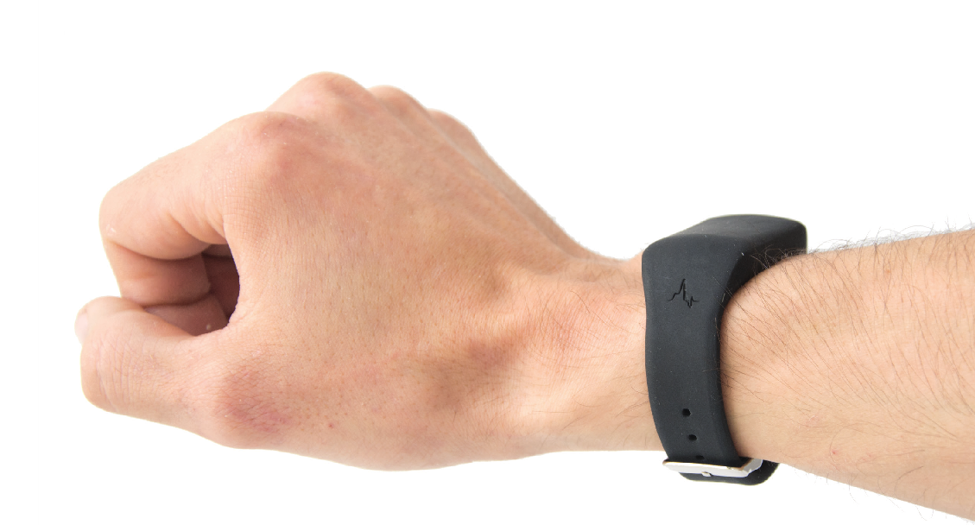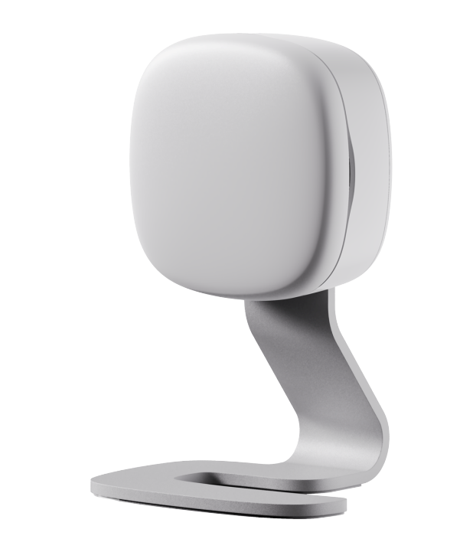

**Wrist-Worn Sleep Sensor**

**Bedside**

**Sensor**

# What you need to do to fit the wrist sensor

1. Fit the wrist worn sensor
2. Either the left or right wrist can be used, but you must not change this during the study
3. Please remove the sensor for bathing, showering or swimming but keep it on at all other times including at night
4. Please try to keep the area around the wrist strap clean and dry
5. Please monitor your wrist for any signs of skin irritation. If this happens, please remove and contact us
6. If you remove the sensor for swimming or taking a shower, and you forget to put it back on, don’t worry, just put it back on as soon as you can.

# What you need to do to fit bedside sensor

1. Place the sensor on a table next to the bed. Please ensure the sensor is approximately 40cm from the bed if possible. Please see below for safety information when fitting the sensor.
2. Plug in the USB plug and connect to the sensor
3. The sensor will record automatically; you do not need to do anything except ensure that it remains plugged in for the duration of the study. If the sensor is accidently unplugged, then please try to plug it in as soon as you can to avoid data loss
4. There is no way that you can tell if the sensor is working, but we will contact you by email if it is not transmitting data to us

Your safety is very important to us. When fitting the sensors please ensure that you take the following precautions:

try to plug the sensor in as close to the wall socket as possible, while still within appropriate range of the bed

run the cord/wire along the wall where possible avoid trailing the wire across the room or walkways consider taping the wires to the wall or floor

What happens next?

When we receive the equipment back at our laboratory, we will analyse your results.

Please be aware that this is a research study and we do not yet fully understand how the data will relate to health and wellbeing.

If you have any problems or questions, you can always contact the research team:

AmbientBD@mu.ie (mailto:AmbientBD@mu.ie) or on the research group phone 087 199 8589

# Summary

Fit the wrist sensor

Fit the bedroom sensor

After 3 months post all equipment and questionnaires back to us in the post-paid envelope. We will send you an email reminder when three months have passed and it is time to end the study

**Thank you very much for your support with our research**